**Applied Physics Lab 8**

**Submitted By: Daud Nasir Cheema (209563)**

**Task 1:**

**Welcome.js(without event handler):**

**Welcome.js:**

import React from 'react';

import logo from './logo.svg';

import './App.css';

class Welcome extends React.Component{

constructor(){

super()

this.state={message:'welcome visitor'}

}

render(){

return <h1>{this.state.message}</h1>

}

}

export default Welcome;

**App.js:**

import React from 'react';

import logo from './logo.svg';

import './App.css';

import Welcome from './Welcome'

class App extends React.Component{

render(){

return (

<div className="App">

<Welcome/>

</div> );

}

}

export default App;

**Output:**



**Welcome.js(with event handler):**

**Welcome.js:**

import React from 'react';

import logo from './logo.svg';

import './App.css';

class Welcome extends React.Component{

constructor(){

super()

this.state={message:'welcome visitor'}

}

changeMessage(){

this.setState({

message: 'Thank you for subscribing'

})}

render(){

return <div>

<h1>{this.state.message}</h1>

<button onClick={()=>this.changeMessage()}>Subscribe</button>

</div>

}

}

export default Welcome;

**App.js:**

import React from 'react';

import logo from './logo.svg';

import './App.css';

import Welcome from './Welcome'

class App extends React.Component{

render(){

return (

<div className="App">

<Welcome/>

</div> );

}

}

export default App;

**Output:**



**1st Counter Program:**

**Counter.js (without setstate):**

import React,{Component} from 'react';

class Counter extends Component {

constructor(){

super()

this.state={ count:0 }

}

increment(){

this.state.count=this.state.count+1

console.log(this.state.count)

}

render(){

return(

<div>

<h1>counter - {this.state.count}</h1>

<button onClick={()=>this. increment()}>Increment</button>

</div> )} }

export default Counter

**App.js:**

import React from 'react';

import logo from './logo.svg';

import './App.css';

import Counter from './Counter'

class App extends React.Component{

render(){

return (

<div className="App">

<Counter/>

</div> );

}

}

export default App;

**Output:**

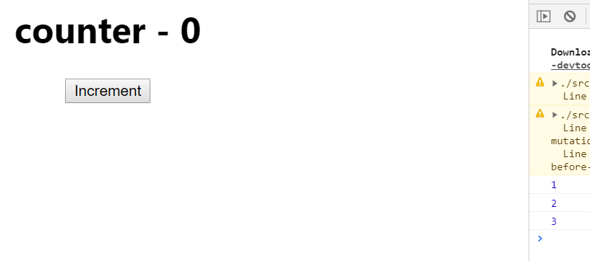

**2nd Counter Program:**

**Counter.js (without callback):**

import React,{Component} from 'react';

class Counter extends Component {

constructor(){

super()

this.state={ count:0 } }

Increment(){

this.setState( {

count:this.state.count+1})

console.log(this.state.count)

}

render(){

return(

<div>

<h1>counter - {this.state.count}</h1>

<button onClick={()=>this. Increment()}>Increment</button>

</div> )} }

export default Counter

**App.js**

import React from 'react';

import logo from './logo.svg';

import './App.css';

import Counter from './Counter'

class App extends React.Component{

render(){

return (

<div className="App">

<Counter/>

</div> );

}

}

export default App;

**Output:**

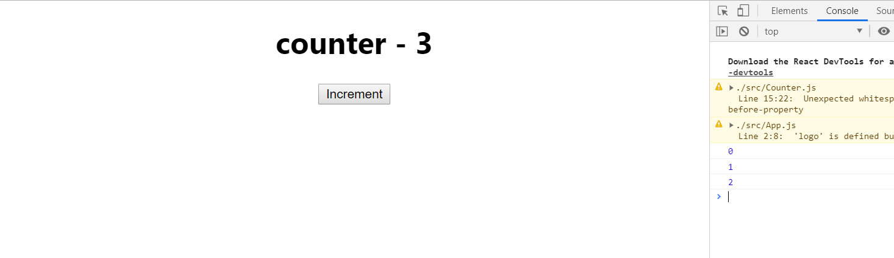

**3rd Counter Program**

**Counter.js (with callback):**

import React,{Component} from 'react';

class Counter extends Component {

constructor(){

super()

this.state={ count:0 } }

Increment(){

this.setState( {

count:this.state.count+1}, ( )=>{console.log('call back value',this.state.count) })

console.log(this.state.count)

}

render(){

return(

<div>

<h1>counter - {this.state.count}</h1>

<button onClick={()=>this. Increment()}>Increment</button>

</div> )} }

export default Counter

**App.js**

import React from 'react';

import logo from './logo.svg';

import './App.css';

import Counter from './Counter'

class App extends React.Component{

render(){

return (

<div className="App">

<Counter/>

</div> );

}

}

export default App;

**Output:**

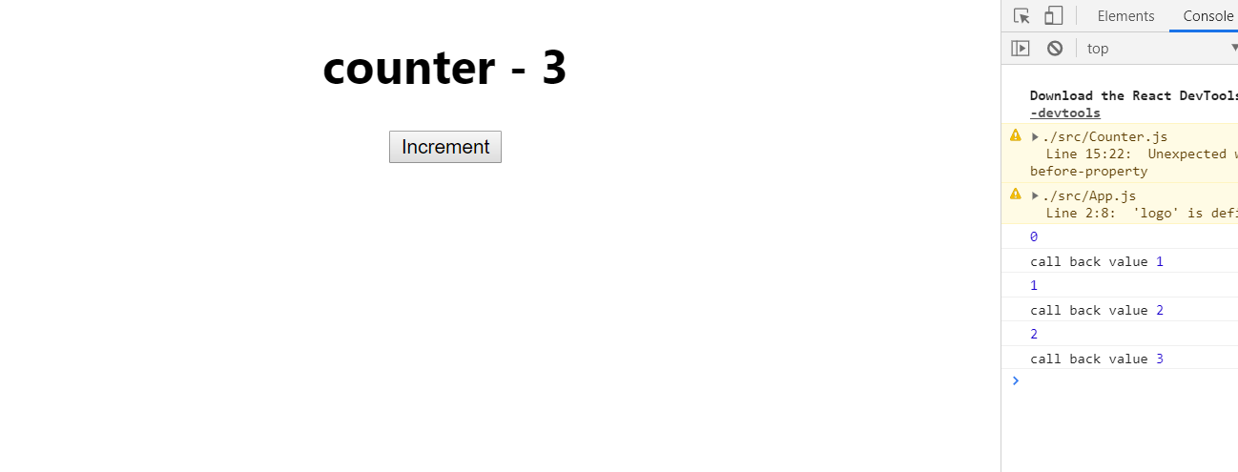

**4th Counter Program:**

**Counter.js (increment five one):**

import React,{Component} from 'react';

class Counter extends Component {

constructor(){

super()

this.state={ count:0 }

}

increment(){

this.setState( {

count:this.state.count+1}, ( )=>{console.log('call back value',this.state.count) })

console.log(this.state.count)

}

incrementFive() {

this.increment()

this.increment()

this.increment()

this.increment()

this.increment()

}

render(){

return(

<div>

<h1>counter - {this.state.count}</h1>

<button onClick={()=>this. incrementFive()}>Increment</button>

</div> )} }

export default Counter

**App.js**

import React from 'react';

import logo from './logo.svg';

import './App.css';

import Counter from './Counter'

class App extends React.Component{

render(){

return (

<div className="App">

<Counter/>

</div> );

}

}

export default App;

**Output:**

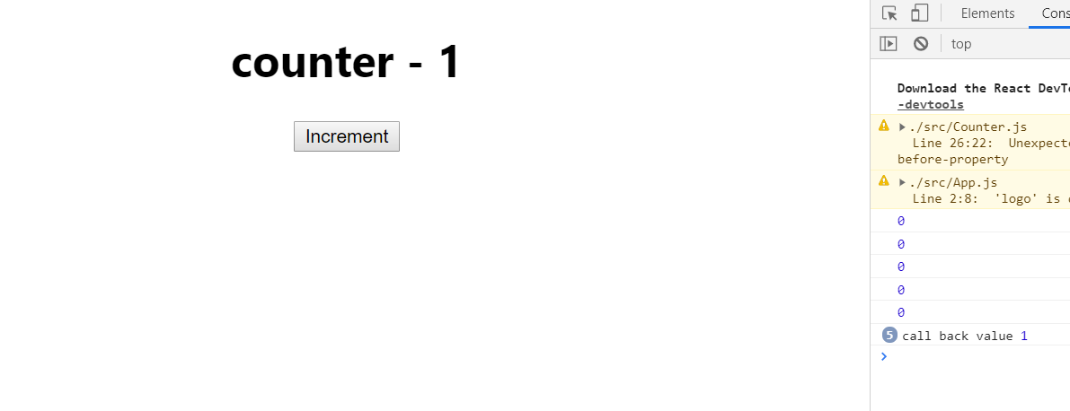

**Task 2:**

**Code:**

import React from 'react';

import logo from './logo.svg';

import './App.css';

class App extends React.Component {

constructor(){

super();

this.state={

min:0,

sec:0,

timer:0

}

this.startClock = this.startClock.bind(this);

this.resetClock = this.resetClock.bind(this);

this.countDown = this.countDown.bind(this);

this.setTimer = this.setTimer.bind(this);

}

resetClock(){

clearInterval(this.state.timer);

this.setState({

min:0,

sec:0,

timer:0

})

}

setTimer(event){

if(this.state.timer==0) // we havent click start timer buttton yet. changing input shall change the timer displayed. after timer has started, changing input should not change it.

this.setState({

min:event.target.value

})

}

countDown(){

this.setState({

sec:this.state.sec-1 // decreasing seconds

}, ()=>{

if(this.state.sec<0) // if seconds reach zero, reset them to 59, and reduce min

{

this.setState({sec:59, // reset seconds to 59

min:this.state.min-1 // reducin minutes

}, ()=>{

if(this.state.min < 0) // timer has reached 0

{

clearInterval(this.state.timer); // stop timer

this.setState({min:0, sec:0, timer:0});

}

})

}

}

)

}

startClock(){

if(this.state.min >0 && this.state.timer==0) // positive minute and timer not started yet

{

this.state.timer=setInterval(this.countDown, 1000);

}

}

render(){

return <div className="App">

<div>

<h3>Input your desired time (positive integer)</h3>

<input type="text" onChange={this.setTimer}/>

</div>

<div><button onClick={this.startClock}>Start</button></div>

<div><button onClick={this.resetClock}>Reset</button></div>

<h1>{this.state.min}:{this.state.sec}</h1>

</div>

;}

}

export default App;

**Output:**

